- GCA Testing
Governance Assessment
- Score Indicator :
Paging is not Provided ----------------------------------------(Fixed By Akhilesh)
Max value Should not be less than Min value (validations in Api ) ----------------- (Fixed By Akhilesh)
Validation message is coming wrong ------------------------------(Fixed By Akhilesh)
- Competency Skill Level:
Paging is not Provided ----------------------------------------(Fixed By Akhilesh)
Positions Are not visible in grid --------------------------------(Fixed By Akhilesh)
Validation Error messages is not provided correctly in edit Functionality ------(Fixed By Akhilesh)
3.Key Improvement Indicators:
Paging is not Provided ----------------------------------------(Fixed By Akhilesh)
Validation is not provided that if Already record is existing with same combination it Should Show error message (validation Should add in api ) ------------------------------------------------------------------(Fixed By Akhilesh)
4 . Define Type :
Paging is not Provided ----------------------------------------(Fixed By Akhilesh)
Page count is not visible -------------------------------------------- (Fixed By Akhilesh)
5. Define sub Type :
Paging is not Provided ----------------------------------------(Fixed By Akhilesh)
Page count is not visible -------------------------------------------- (Fixed By Akhilesh)
Trim condition is not provided --------------------------------------( Fixed By Akhilesh)
6.Assessment Builder:
Stepper1
In Competency check level and Random selection :
Enter Number of Questions Should be Rusticated----- ----------------------
By deselecting the sub-Topics Questions Are not getting decreased correctly-------------
By Deselecting the Topics again selecting the sub-Topics Automatically checked in ---------------
By Deselecting the Topics Questions Are not getting Decreased & in cat 1, cat2,cat 3 validation is not provided for strictest selection of questions for available questions .--------------------
Show over question count and available question in validation / proper validation message------------
Stepper 2
IN Remove Questions Grid Add columns choose and page count ---------------------------(fixed Akhilesh)
In Add Question While creating Question in valid Question is coming –
Select Question(s) to be added: grid count and paging is not working
No proper validations are proved for Add Question in
Removed Question TO Add again is not Showing in Any page -----------
7.Customized Assessment ----- NOT tested
8.View Assessment template ----------------N/A
9. Update Assessment Template .
IN Remove Questions Grid Add columns choose and page count ---------------------------
Add Question Proper validations Are not provide---------------
In Add Questions tab Exit Button is not working ----
In Add Questions Back Tabs Are not provided --------------
10.Disable Assessment Template
validation is not working--------
11. Reactivate Assessment Template
After Activating the Record again showing in grid --------
12. Assessment Result ---------- NOT Tested
Groverance Question Bank
- Define Subject:
Paging is not Provided ----------------------------------------(Fixed By Akhilesh)
2.Define Topic
Paging is not Provided ----------------------------------------(Fixed By Akhilesh)
3.Check-Level
Paging is not Provided ----------------------------------------(Fixed By Akhilesh)
Count is not Showing ----------------------------------------(Fixed By Akhilesh)
4.BulkUpload of Question
Remove Values from template ------------------------------
5.Edit Question
Not Able to see the Answer in options but Still it is getting updated --------
Remove Un wanted Alerts & After successfully update of Question All fields Are not getting cleared ----
6.Disable Question
Validation message is not Showing correctly--------
After Disable again Showing the list Page Should be reloaded ----------(Fixed Akhilesh)
7.Reactivate Question
After Reactivating again Showing the list Page Should be reloaded ----------(Fixed Akhilesh)
8. My Questions
Not Able to see the Options for selected Questions ---------------------------

13.Map Assessment Template Access
Mapped user list : changes of header and search -----(Fixed Akhilesh)
1.Edit Access
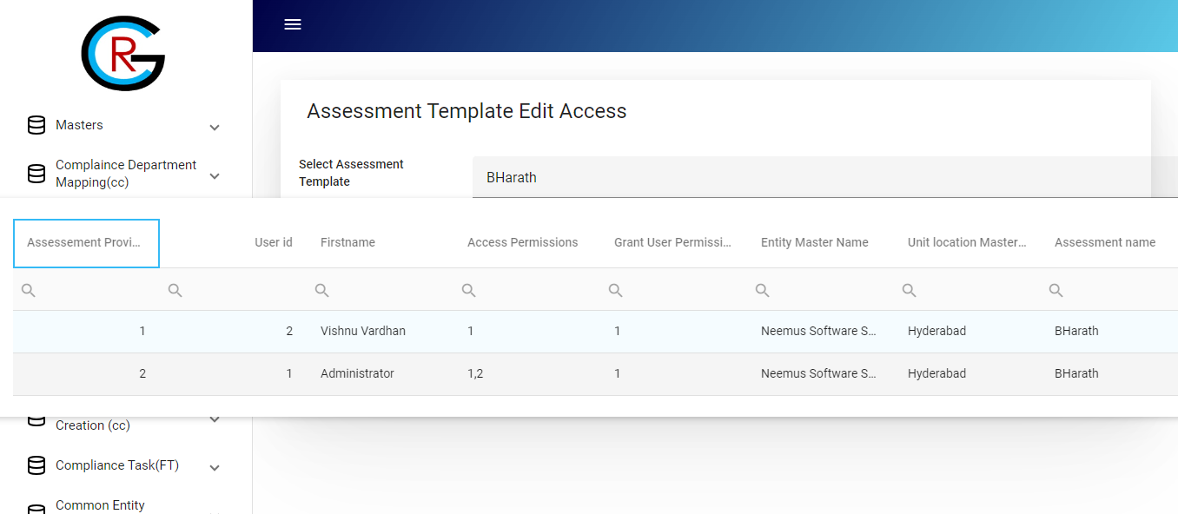

Getting Values not Able to see the Fields With proper names----------

2.Remove Access
Getting Values not Able to see the Fields With proper names----------

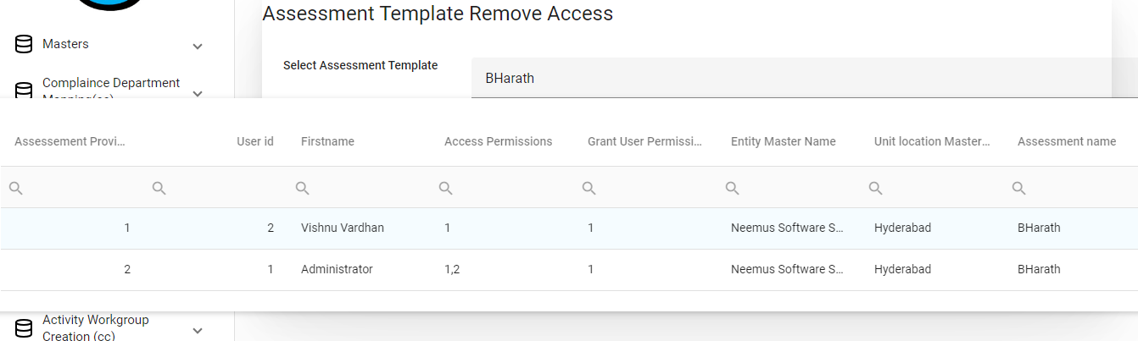

Reload the component After Removing or Updating the Access------

14.Scheduled Assessment
1. Repeat Frequency
Header In braces (Internal -----I Should be capital)
If onces Toggles is checked fields parameters Are fetching but when toggle is unchecked Still Fields Are Visible

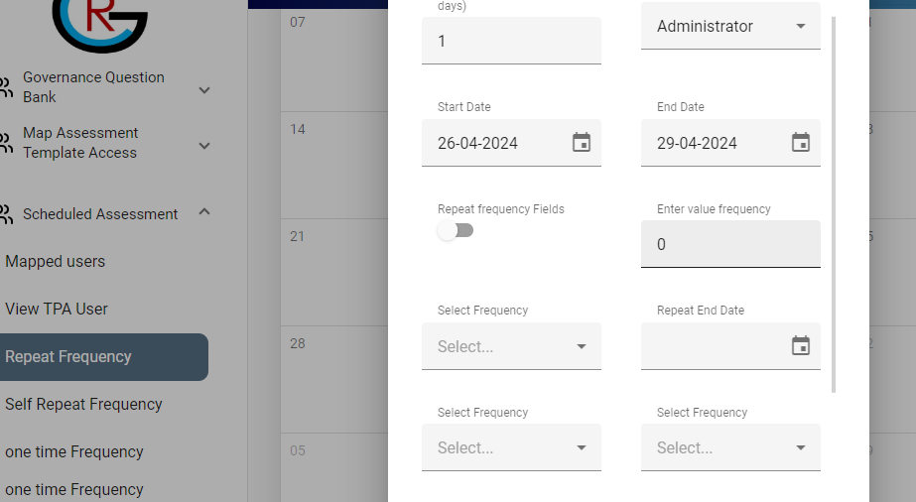

When I click on the cancel button Schedule is closing but Still the Next Button is visible . Still I fill tha Details to Scheduled Assessment is Done then only Button Should visible
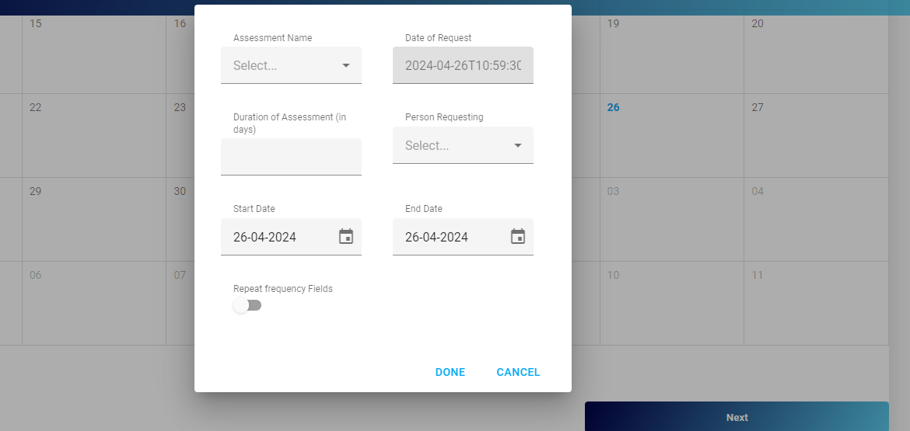
Validations are not Provided Empty Scheduled is Done

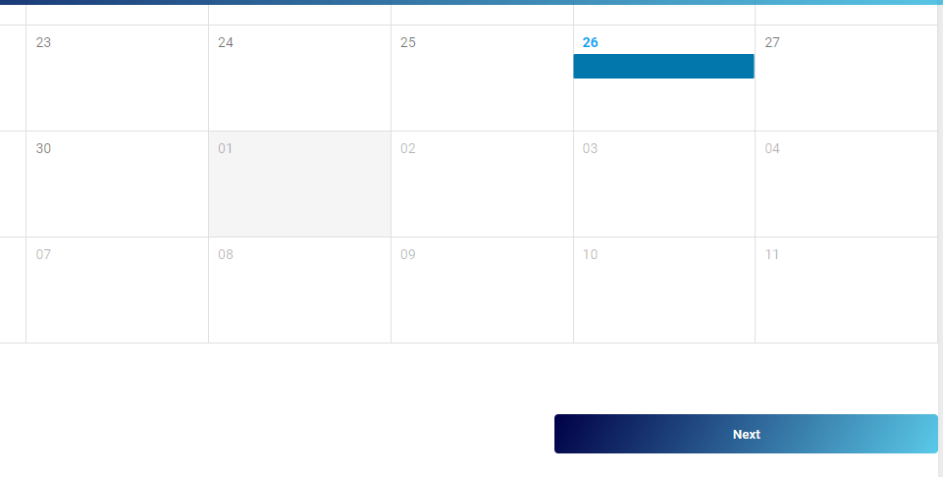
With Empty Selection Repeat Frequency is Scheduled
2.self repeat Frequency

